KineDok will launch a manual on How to Set Up a Screening Venue
March 27, 4:30 PM (GMT+1), Kino 35 (Štěpánská 644, Prague 1)
How to proceed step by step in organizing a screening? Films don't have to be screened only in a cinema, but also in a café, gallery, library or on a boat. KineDok, thanks to its long-term experience in organizing screenings in alternative venues, is preparing a manual consisting of examples of good practice. It will be published digitally on 27 March during East Doc Platform 2024.
KineDok has been operating since 2014 as an alternative distribution platform and during this time we have managed to create a network of almost 250 non-traditional screening venues in 6 countries in Central and Eastern Europe. Partners from all these countries – Czech Republic, Slovakia, Romania, Hungary, Croatia and Georgia – have collected valuable data from their experience.
In the manual we want to share our expertise and case studies based on our long-term cooperation with KineDok venues. Individual chapters will reveal practices and offer readers tips on how to organise community screenings with accompanying programme in unconventional venues. The manual will serve as a starting point for new screening venues or perhaps students who want to start film clubs, as well as for anyone planning to organize cultural events in non-cinema spaces.
"We wanted to create a simple guide on community distribution, containing experiences of organizing cultural events, which can inspire both young people and more experienced community centre managers who decide to organize film screenings. How to Set Up a Screening Venue will include short readable chapters with examples, images and videos, with brief points on what not to forget at key stages of organizing an event such as film selection, technical facilities or communicating with the audience and reaching out to new groups. Our international initiative of culture warriors thus offers their stories as a guide on How to Set Up a Screening Venue and motivates others who decide to revive culture in their cities," says KineDok manager Ivana Formanová.
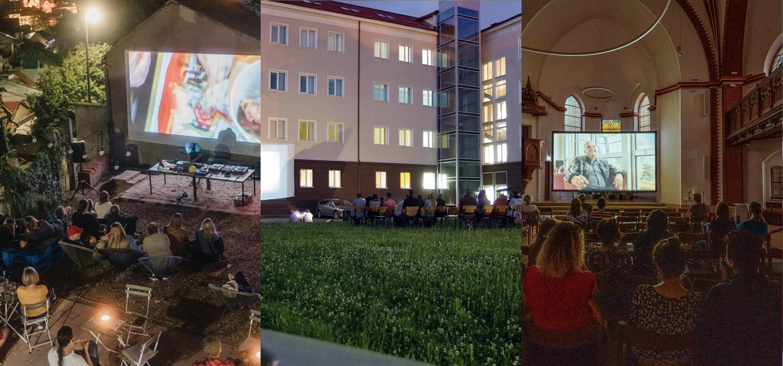
Photos from KineDok screenings, from left: Kinodomino in Hungary (authors: Lili Nagy-Peti and Dániel Kovács), Muzeul Cineastului Amator in Romania and the Červený kostel in the Czech Republic (author: Radka Piskačová).
The launch of the manual will take place during a conference on 27 March at 4:30 PM (GMT+1) in Prague's Kino 35 as part of the East Doc Platform, the largest platform for acquiring international partners for co-production, financing and distribution of documentary projects in Central and Eastern Europe, organized by the Institute of Documentary Film in cooperation with the One World International Film Festival.
The manual will be published and made available digitally for a free download (PDF) on kinedok.net. It will also be available here and on dokweb.net in interactive form. It is divided into ten chapters and edited by film curator Hana Kulhánková.

1. Are Documentaries Documenting? (František Horvát, Czech Republic)
2. Building Blocks of Your Community (Veronika Hanáková, Czech Republic)
3. On The Diversity of Venues (Szirony Szabolcs, Hungary)
4. Navigating Technical Hurdles (Mariam Jachvadze, Georgia)
5. How to Pick the Right Films (Andreea Bratosin, Romania)
6. Continuous Communication with the Audience (Mária Hejtmánková, Slovakia)
7. Dear Audience: Who are you? (Dina Pokrajac, Croatia)
8. Film Screenings under Pressure (Mariam Jachvadze, Georgia)
9. Too Cool for School: Building Young Audiences (Dina Pokrajac, Croatia)
10. How to Join KineDok (Szirony Szabolcs, Maďarsko)

KineDok is a project of the Institute of Documentary Film. This project is supported by Creative Europe MEDIA, International Visegrad Fund, US Embassy, The Czech Film Fund and the Prague City Hall.

About Institute of Documentary Film
The Institute of Documentary Film (IDF) has been supporting creative documentary films from Central and Eastern Europe since 2001. The IDF provides both emerging and experienced filmmakers with training, financing, networking and pitching opportunities, helps them get international attention and co-productions, rewards the exceptional projects with Awards and further opportunities and improves their orientation on the international market. The promotional and practical service of the IDF includes a wide range of online and offline catalogues being created annually, updating a thorough database of CEE documentaries and professionals and a calendar of important deadlines for producers, and bringing news from the world of documentary film in general via dokweb.net and social media. To the audience of documentary enthusiasts, the IDF also brings a rich programme of lectures, presentations and screenings in their home regions or during the IDF’s industry events.
dokweb.net
About KineDok
KineDok is a community-driven distribution of creative documentary films outside cinemas. We connect a network of 200 untraditional venues across 6 European countries. We invite you to places like galleries, coffee shops, and even boats. Screenings are accompanied by discussions with filmmakers and guests. The project is one of the activities of the Institute of Documentary Film.
kinedok.net

