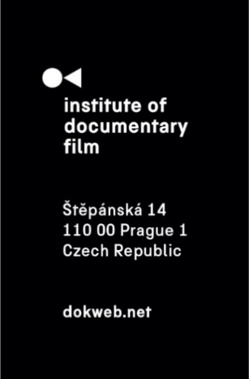
Press Release, Prague, 4. 6. 2025

KineDok unveils bold new 2025/26 documentary collection

KineDok, the international community-based documentary distribution project of the Institute of Documentary Film, proudly presents its brand-new 2025/26 curated collection: a striking lineup of 16 full-length documentaries and a unique block of archival short films. These works will be available for screenings from May 2025 across Czechia, Slovakia, Hungary, Croatia, and Romania.

The new catalogue features bold, award-winning titles that challenge traditional storytelling, explore personal and political transformation, and give voice to often-overlooked communities. From animated reenactments of post-communist chaos to photographic journeys of artistic resistance, these films promise to move and inspire.

"The new KineDok film collection is without a doubt one of the best we’ve ever curated in the history of the project. Together with our international partners, we’ve had the opportunity to assemble an exceptionally strong catalogue of documentary films – titles that are winning awards at international festivals while also surprising audiences with their boldness, playfulness, and openness in both form and theme,“ says Ivana Formanová, KineDok Manager.

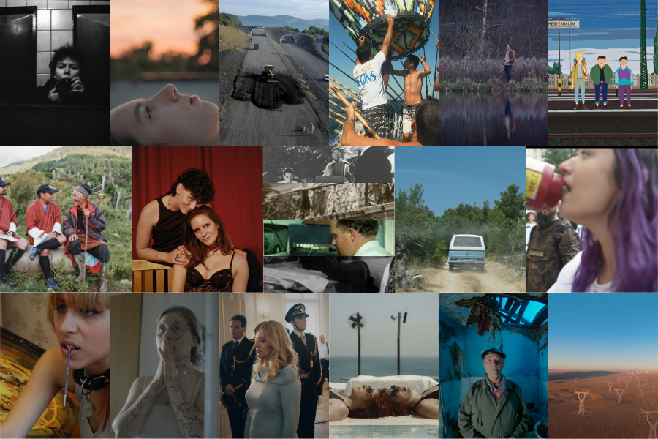

Screenings will be organized either directly by KineDok or hosted by its signature non-traditional venues—cafés, galleries, barns, and boats—spaces that spark conversation and bring communities together. The full programme is available at: https://kinedok.net/events.

KineDok also welcomes new venues. Hosting a screening is free and easy—ideal for anyone interested in bringing fresh perspectives and meaningful dialogue to their local community. Apply here: https://kinedok.net/join-us.
Want to know more first? Explore KineDok’s screening manual here: https://kinedok.net/chapters.

Selected documentary films
I’m Not Everything I Want to Be (Klára Tasovská, 2024, Czechia, Slovakia, Austria, 85 mins)
A self-portrait of an artist seeking freedom, seen through the camera lens of Libuše Jarcovjáková. Hailing from communist Czechoslovakia, her extensive photograph collection takes audiences between three cities in her early career.

The Other One (Marie-Magdalena Kochová, 2024, Czechia, Slovakia, 87 mins)
As she steps into adulthood, a young woman must reconcile her longing for independence with the fear of abandoning her sister, who lives with atypical autism. A coming-of-age documentary exploring responsibility, self-love, and the deep bonds of sisterhood.

Byeway (Ivo Bystřičan, 2014, Czechia, 75 mins)
A documentary about the never-ending construction of the D8 highway meant to connect Prague with Germany. Instead, it split the landscape and society—becoming a symbol of state dysfunction, legal disputes, and local frustration.

Shadows of History (Vladimir Kressl, Judit Elek, Krsto Papić, Slavomir Popovici, 2025, Czechia, Slovakia, Hungary, Croatia, Romania, 69 mins)
Block of four short films from the 1960s and 1970s, produced in four KineDok project countries. These films offer a glimpse into the recent past of each country, as found in their film archives.

A Gifted Town (Vladimir Kressl, Czechoslovakia, 1965, 11 min)
This film raises questions that echo throughout the entire program: how do we, in the present, access history; how can film become an accomplice in distorting historical truth; what is there to say about the credibility of the (film) archives? A would-be documentary from the Nazi-era is exposed as having been counterfeit: a collection of drawings and archival documents serve to restore the dark truth.

Inhabitants of Castles (Judit Elek, Hungary, 1966, 28 min)
Inhabitants of Castles explores built heritage—the physical, tangible remnants of history—by observing the social lives of the imperial castles repurposed by the state in socialist Hungary, and the perishable memory of the past following the physical disappearance of those who witnessed it.

Let Our Voices Be Heard (Krsto Papić, Yugoslavia, 1970, 16 min)
The third film shifts focus to intangible heritage, exploring the now-extinct pirate radio stations that once emerged in rural Yugoslavia, acting as vital catalysts for popular mobilization.

The Journals of Hrib (Slavomir Popovici, Romania, 1974, 15 min)
The Journals of Hrib returns to the topic of material heritage: an self-taught peasant opens a museum dedicated to local traditions in his home in rural Bukovina. Today we know that the museum did not survive its custodian, who passed away shortly after the fall of the Ceaușescu regime. The pressures and ambitions brought on by the new capitalist order of the 1990s quickly led to the museum's dissolution, alongside the destruction of the plants, factories and film studios left behind by the former regime.

Balomania (Sissel Morell Dargis, 2024, Denmark, Spain, 93 mins)
With police and bounty hunters hot on her heels, a young filmmaker embarks on a wild ride with a Brazilian brotherhood of balloon builders as they launch into the sky spectacular balloons over 70 metres large. An intimate and explosive story of community, freedom and self-expression.

A Silent Story (Anders Skovbjerg Jepsen, 2023, Denmark, Sweden, 88 mins)
A man unravels his trauma and seeks answers from a childhood friend who sexually abused him. This autobiographical film captures his complicated, long journey for closure as he confronts the past.

Pelikan Blue (László Csáki, 2023, Hungary, 79 mins)
After the fall of the Soviet Union, Hungary’s youth dream of exploring the world — but with no money, adventure seems out of reach. Three young men find a daring solution: master the art of forging international train tickets.

Agent of Happiness (Arun Bhattarai, Dorottya Zurbó, 2024, Hungary, Bhútán, 2024)
What does it mean to measure happiness? In Bhutan, agents survey and converse with people door-to-door to help measure the country’s Gross National Happiness, but these agents must search for their personal happiness as well.

Grand Prize (Anja Koprivšek, 2024, Croatia, 46 mins)
In a society where being LGBTQ+ often means living on the margins, Teo—a young trans man—finds community and support in Valentina, an experienced ballroom dancer. Their connection quietly deepens as they navigate everyday life and personal change.

The Ground Where We Stand (Karla Crnčević, 2024, Croatia, 65 mins)
In the remote interior of the island of Brač, a group of women lives in a self-sufficient utopia — but when the issue of land ownership arises, the very foundation of their community is threatened.

Imaginary Youth (Ruxandra Gubernat, 2024, Romania, 84 mins)
Three high school seniors—Una, an aspiring actress, Habet, a trap artist, and Stefania, an environmental activist—face the uncertainties of their future plans as the Covid pandemic upends their lives. Forced to reassess their dreams of studying abroad, they grapple with self-discovery, societal pressure, and the reality of growing up.

Alice On & Off (Isabela Tent, 2024, Romania, 84 mins)
A documentary portrait of a girl who began living the life of an adult at sixteen, yet her own pain and trauma keep her from truly growing up. Over the course of ten years, she repeatedly tries to find herself and reconnect with her son.

Grey Zone (Daniela Meressa Rusnoková, 2024, Slovakia, 80 mins)
An authorial documentary directed by Daniela Meressa Rusnoková that brings a sensitive perspective on the little-discussed topic of premature births and saving highly immature infants born in the so-called “grey zone”.

Ms. President (Marek Šulík, 2024, Slovakia, 108 mins)
Pivotal moments of political drama, encounters with world leaders over global dilemmas, and quiet conversations with ordinary citizens about everyday struggles—this documentary follows Slovakia’s president, Zuzana Čaputová, through the turbulent years of her presidency.

Wishing on a Star (Peter Kerekes, 2024, Italy, Slovakia, Czechia, Austria, Croatia, 99 mins)
Luciana, a Neapolitan astrologer, has a method to make her clients’ wishes come true. All they need to do is take a trip on their birthday to a precise destination to be reborn under a new sky.

Fresh Memories: The Look (Ondřej Moravec, Volodymyr Kolbasa, 2023, Ukraine, Czechia, 10 mins)
Can you look into the eyes of those whose lives have been shattered by war? Fresh Memories: The Look is a short Czech-Ukrainian VR film that transports viewers into the heart of bombed-out Kharkiv—one of the cities most devastated by the Russian invasion of Ukraine. Through powerful, direct eye contact, the film shares the emotional stories of local residents affected by the war. Viewers find themselves in ruined apartments, hospitals, and playgrounds, where people silently convey their pain and resilience. Inspired by Marina Abramović’s performance The Artist Is Present, this immersive experience confronts the audience with the raw human face of war.

21-22 CHINA (Thierry Loa, 2022, Canada, 25 mins)
21-22 CHINA presents an immersive, meditative journey across the world’s fastest-growing superpower—a land undergoing rapid urbanization, major industrial development, and massive topographical transformations.

Most films in the collection are available for screenings from May 2025 to April 2026 across all KineDok countries. However, there may be minor exceptions based on territorial rights or release windows. Please check with your local KineDok coordinator for details on film availability in your country.
KineDok is an international community-driven distribution project of the Institute of Documentary Film. This project is supported by Creative Europe MEDIA, Ministry of Culture Czech Republic, Czech Audiovisual Fund and the capital city of Prague.
About KineDok
KineDok is a community-driven distribution of creative documentary films outside cinemas. We connect a network of 200 untraditional venues across 6 European countries. We invite you to places like galleries, coffee shops, and even boats. Screenings are accompanied by discussions with filmmakers and guests. The project is one of the activities of the Institute of Documentary Film.
kinedok.net

About the Institute of Documentary Film
Since 2001, the Institute of Documentary Film (IDF) has been supporting Eastern and Central European original documentary films in all stages of production. It assists emerging and experienced directors with the development of their films, and producers with the financing, distribution and promotion of their films, as well as with orientation on the international market. All this with the help of the vast experiences of renowned international experts. Films supported by IDF activities regularly win awards at leading film festivals. For the public, the IDF organises lectures and screenings of the most interesting documentaries not only in cinemas but also in various alternative spaces.

dokweb.net

Media contact:
Anna Jurková | PR IDF | tel.: +420 605 136 254 | e-mail: jurkova@dokweb.net

